**TASK 1:**

**Practicing GIT commands**

**To initialize a repository:**

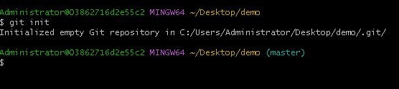

**Created a new file in the GIT repository:**

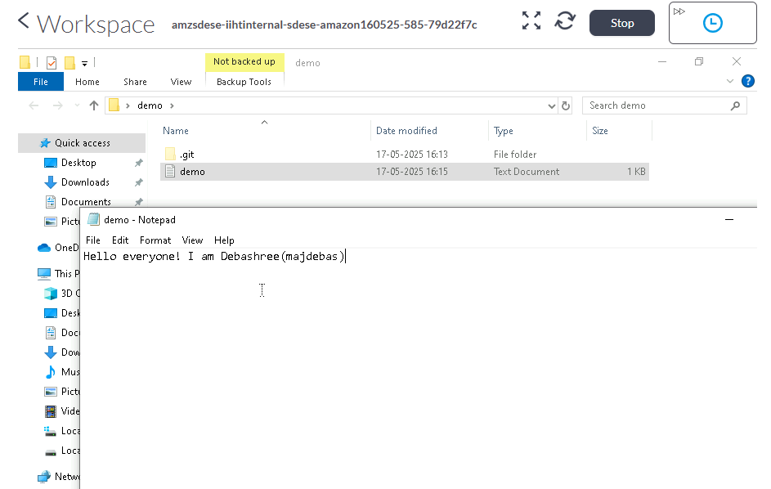

**Added the file to the GIT repository:**

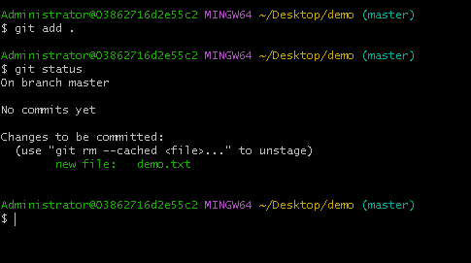

**Committed the file to the GIT repository:**

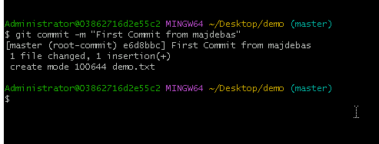

**Pushing local repository to GITHUB repository:**

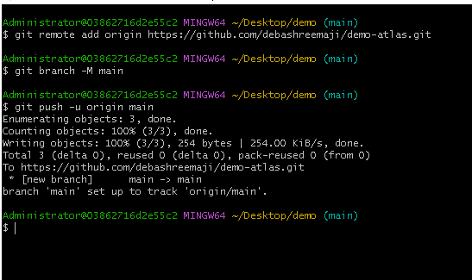

**Inspecting the commit history:**

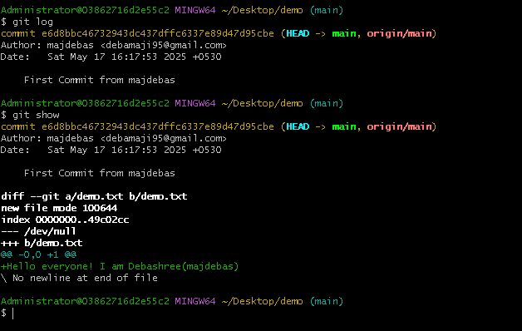

**Adding a gitignore:**

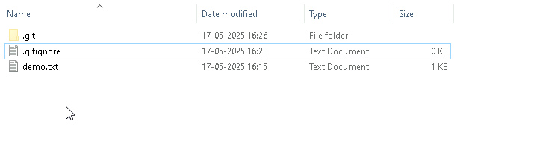**Creating a new branch featurebranch1:**

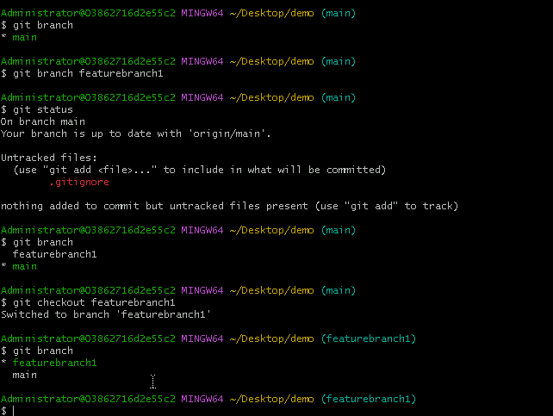

**Creating a commit to the feature branch:**

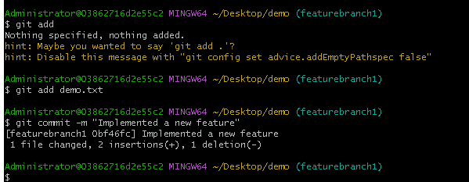

**Merging feature branch to the main branch:**

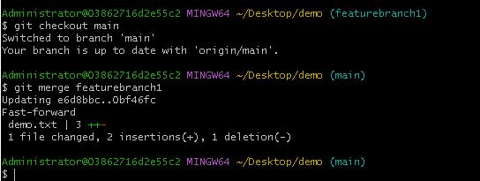

**Pushing feature branch to the GIT repository:**

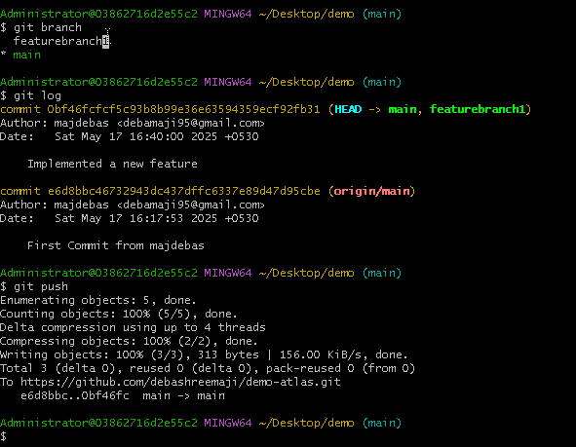

**Exploring GIT GUI :**

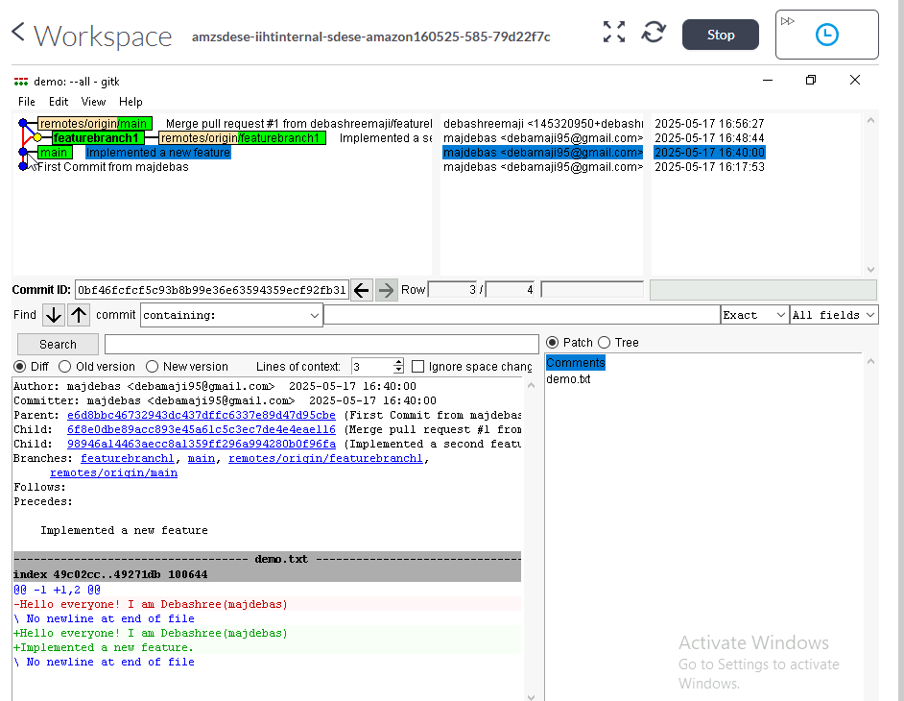

**TASK 2:**

**Can you change the commit msg in the git hub?**

Yes, this modifies the most recent commit.

git commit --amend -m "New message"

git push --force branch_name